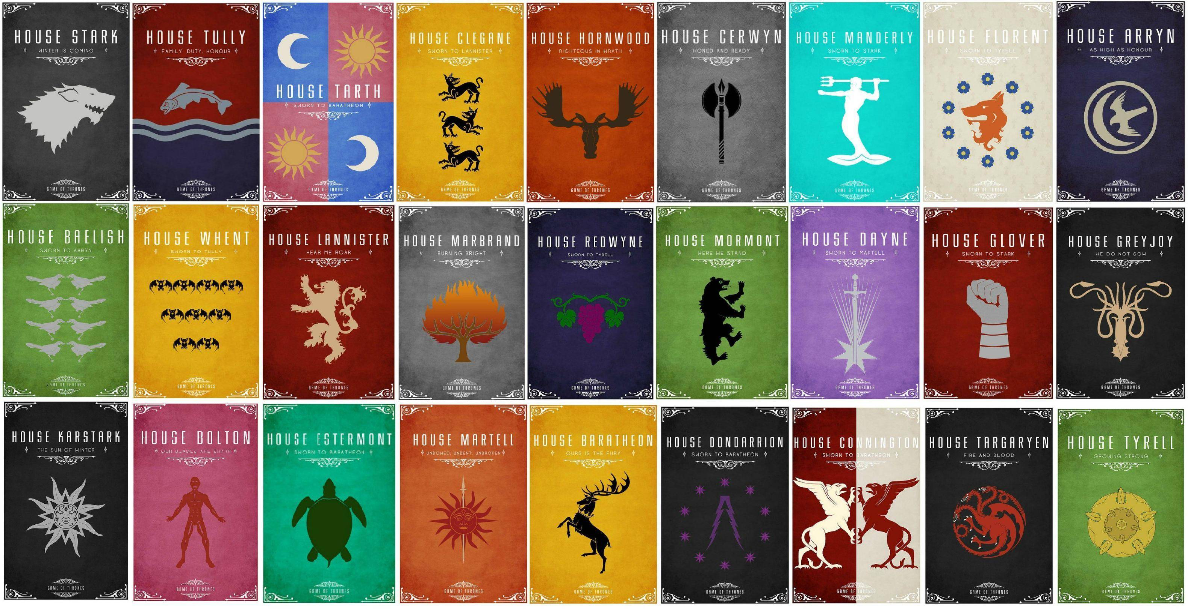
Stark - #3c3c3c, #c4c4c2
tully - #2b2644, #7b170d, #7b8891
tarth - #4d7bc8, #b65d6c, #d2a758, #e9e2d2
clegane - #dba711, #010203
hornwood - #b73f09, #382916
cerwyn - #767676, #010101
manderly - #10d4ca, #ffffff
florent - #e0dcc8, #cc5f27, #32558d, #cec670
arryn - #2c2842, #b7b296
baelish - #66943b, #abaaa9
whent - #dba615, #040a0a
lannister - #7a160c, #cfaa82
marbrand - #6d6d6d, #d67d16, #871d15, #6f4515
redwyne - #2a2448, #710554, #036703
mormont - #68953e, #010101
dayne - #976db7, #bdc3c3
glover - #811a09, #abacaa
greyjoy - #242424, #cbab82
karstark - #212121, #a8a8a8
bolton - #b5506e, #972c22
estermont - #01a77c, #1b3c05
martell - #c15d2c, #971f1e, #d2a882
baratheon - #dca717, #040005
dondarrion - #282828, #562e6c
connington - #6f0f07, #fef7da
targaryen - #222222, #a9301e, #fff9ef
tyrell - #6d9b43, #c8b13e, #ae9836

